Movie Script Analysis

Mikolaj Wieczorek and Marshal Will

12/12/2019

# Motivation

’tis amazing!

# Excecutive summary

blah blah # Data Descirption yes, a lot of work

# Methods used:

many many very much

## Upload Movies

path_85 = "~/OneDrive - MNSCU/myGithub/Unsupervised_Learning/Movie-Script-Unsupervised-Learning-Methods-Analyses/85_movies"  
dir_85 = DirSource(paste(path_85, sep=""), encoding = "UTF-8")  
corpus_85 = Corpus(dir_85)  
head(summary(corpus_85))

## Length Class Mode  
## 500-Days-of-Summer.txt 2 PlainTextDocument list  
## A-Few-Good-Men.txt 2 PlainTextDocument list  
## A-Prayer-Before-Dawn.txt 2 PlainTextDocument list  
## Abyss,-The.txt 2 PlainTextDocument list  
## Alien.txt 2 PlainTextDocument list  
## American-Outlaws.txt 2 PlainTextDocument list

tail(summary(corpus_85))

## Length Class Mode  
## Tomorrow-Never-Dies.txt 2 PlainTextDocument list  
## Vanilla-Sky.txt 2 PlainTextDocument list  
## Visitor,-The.txt 2 PlainTextDocument list  
## War-of-the-Worlds.txt 2 PlainTextDocument list  
## When-a-Stranger-Calls.txt 2 PlainTextDocument list  
## X-Files-Fight-the-Future,-The.txt 2 PlainTextDocument list

ndocs <- length(corpus_85)  
# ignore extremely rare words i.e. terms that appear in less then 1% of the documents  
minTermFreq <- ndocs * 0.15  
# ignore overly common words i.e. terms that appear in more than 50% of the documents  
maxTermFreq <- ndocs * .5  
dtm_85 = DocumentTermMatrix(corpus_85,  
 control = list(  
 stopwords = T,   
 wordLengths=c(4, 15),  
 removePunctuation = T,  
 removeNumbers = T,  
 #stemming = T,  
 #removeWords("bateman"),  
 bounds = list(global = c(minTermFreq, maxTermFreq))  
 ))

#dtm <- dtm[, names(head(sort(colSums(as.matrix(dtm))), 400))]  
#dtm <- dtm[, names(sort(colSums(as.matrix(dtm))))]  
dtm.matrix_85 = as.matrix(dtm_85)  
dim(dtm.matrix_85)

## [1] 85 3182

## Clustering

##### Preparing for clustering ######

#Clustering words  
tdm_85 = t(dtm_85)  
#Removing sparse terms  
tdm_no_sparse_85 = removeSparseTerms(tdm_85, sparse = .99)  
#Cluster  
tdm.mat_85 <- as.matrix(tdm_no_sparse_85)  
#First 20 most frequent words  
word.freq = sort(rowSums(tdm.mat_85), decreasing = T)  
barplot(word.freq[1:20], cex.names = .8)

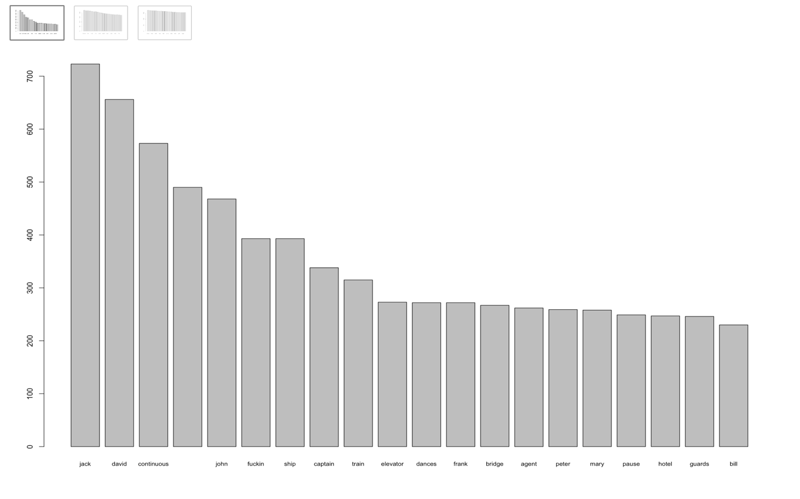

#Next 20 most frequent words  
barplot(word.freq[21:40], cex.names = .8)

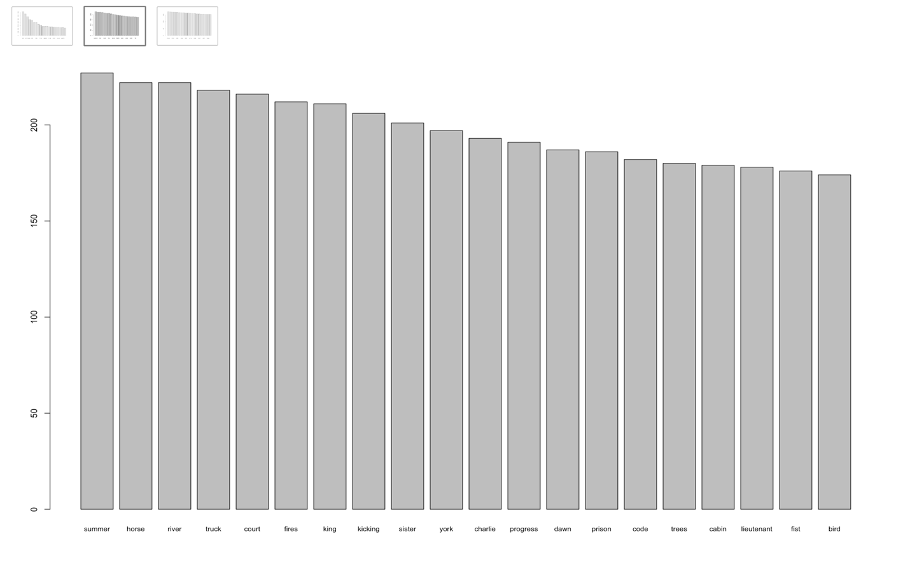

#Next 20 most frequent words  
barplot(word.freq[41:60], cex.names = .8)

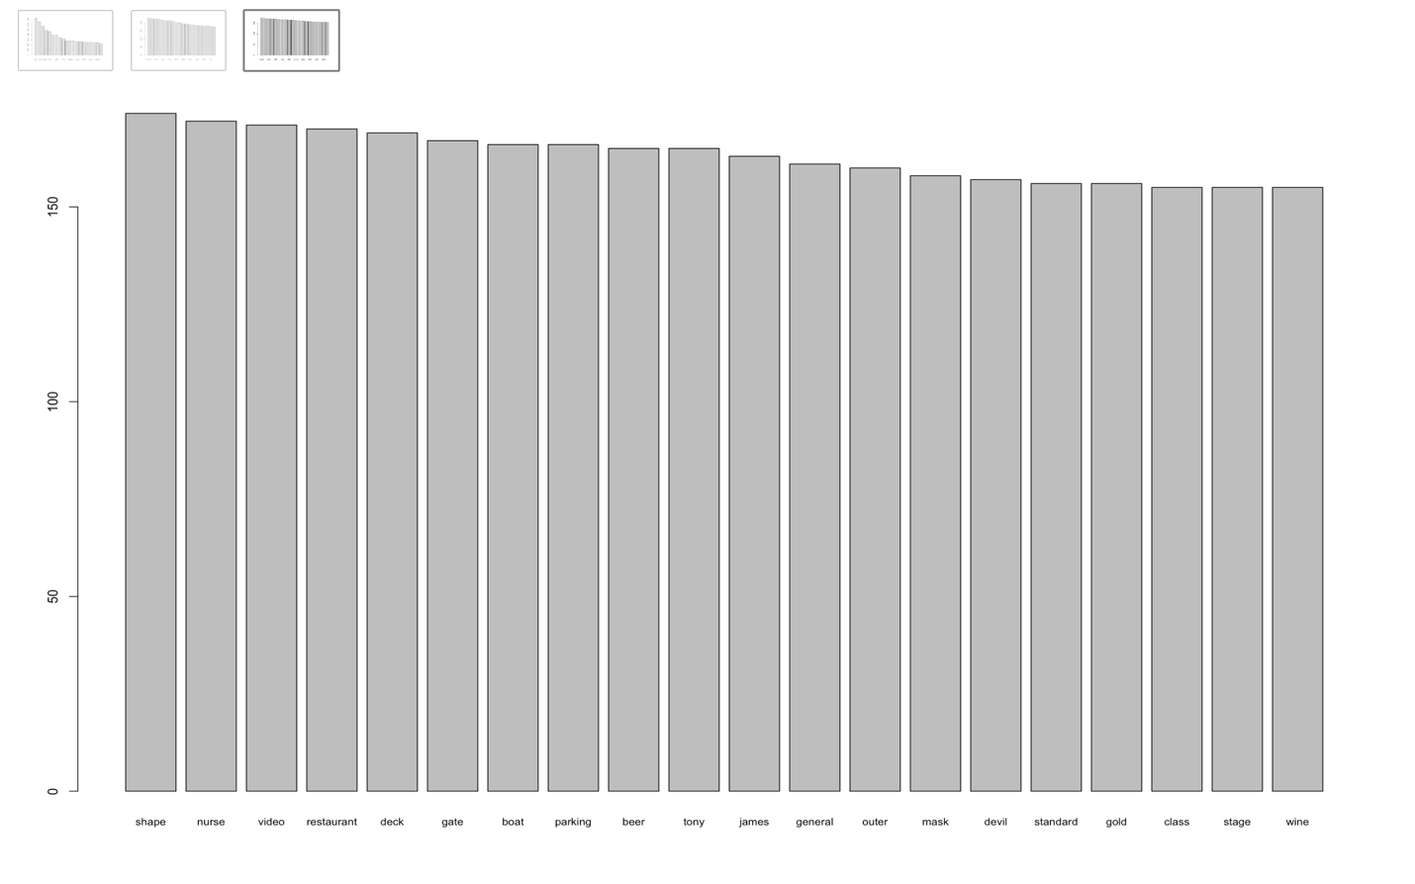

The most common words appear to be:

**fuckin, ship, captain, train, elevator, dances, bridge, agent, hotel, guards,**   
summer, horse, river, truck, court, fires, king, kicking, sister, york,  
progress, dawn, prison, trees, cabin, lieutenant, bird

We are not considering names or words that relate to directions for actors in the movie script; there are still some left out even after cleaning all the 85 scripts in python to generate “spoken words”

### Clustering Words

#Clustering words: words as terms and movies as documents: T-D  
clust.tdm.matrix_85 = as.matrix(tdm_85)  
clust.tdm.matrix_85[clust.tdm.matrix_85>1] = 1

#Using Agnes  
tdm.agnes.ward_85 = agnes(clust.tdm.matrix_85, metric = "Jaccard", method = "ward")

#Plotting Agnes cluster  
plot(tdm.agnes.ward_85,cex = 0.7, which.plots = 2)

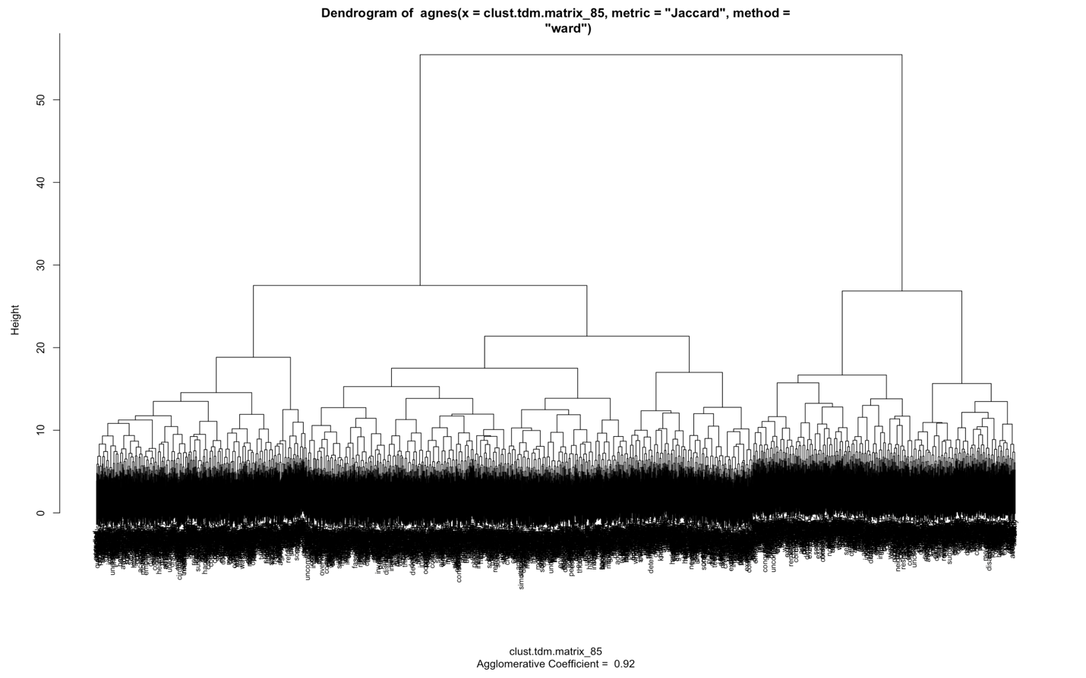

#Using hclust  
tdm.movie.dist_85 = dist(clust.tdm.matrix_85, method = "Jaccard")

#Plotting hlust  
tdm.movie.clust_85 = hclust(tdm.movie.dist_85, method = "ward.D")  
plot(tdm.movie.clust_85, cex = .7)

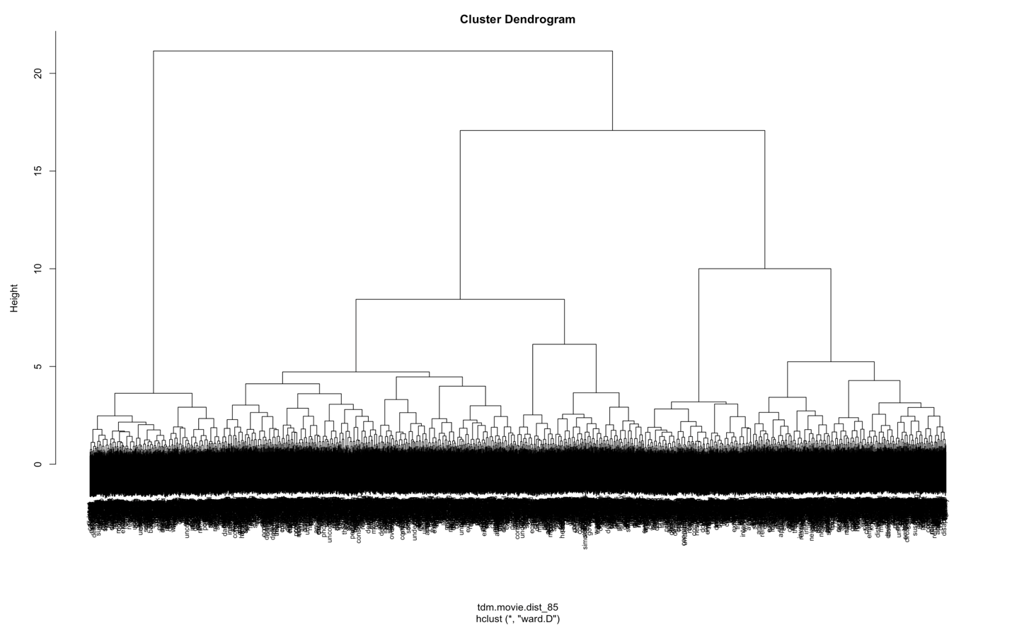

words.groups_85 = cutree(tdm.movie.clust_85, k=25)  
table(words.groups_85)

## words.groups_85  
## 1 2 3 4 5 6 7 8 9 10 11 12 13 14 15 16 17 18   
## 106 106 190 134 142 244 101 117 148 81 292 62 62 138 60 121 147 84   
## 19 20 21 22 23 24 25   
## 150 142 107 52 123 179 94

#### K-means

#Optimal number of clusters  
fviz_nbclust(clust.tdm.matrix_85,kmeans,k.max=15,method="silhouette")

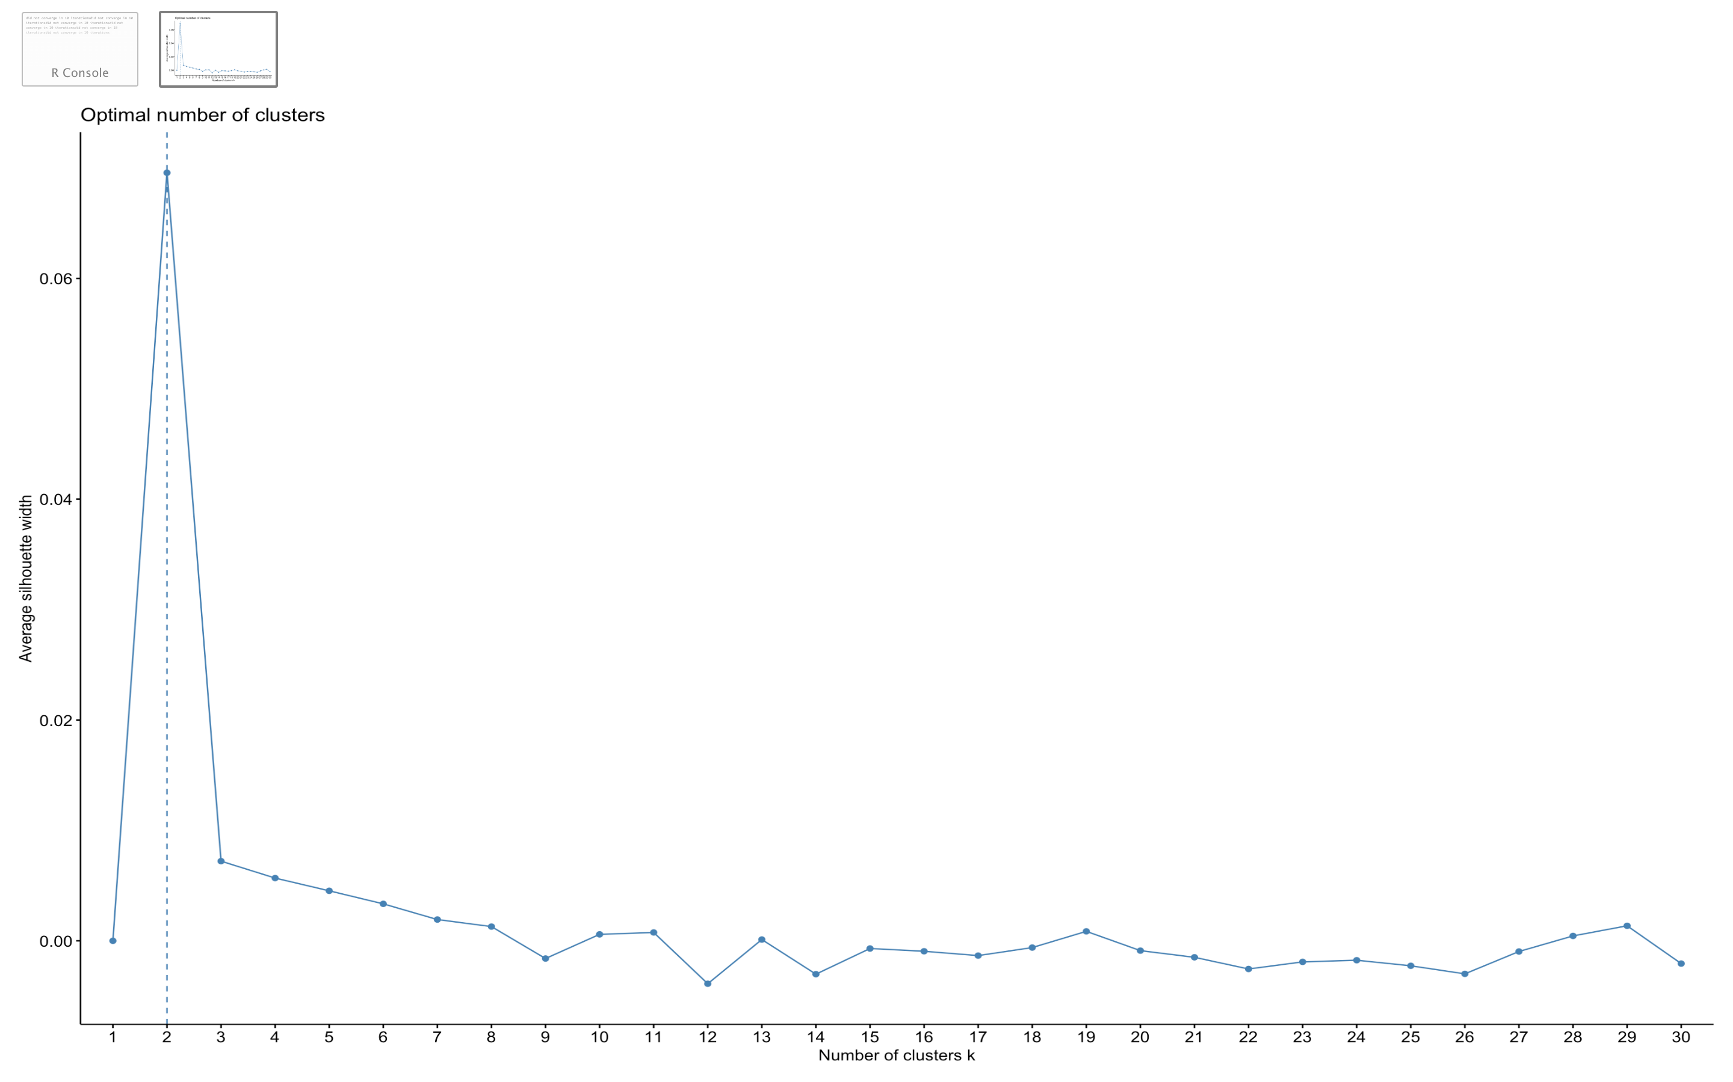

fviz_nbclust(tdm. mat_85,kmeans,k.max=15,method="wss")

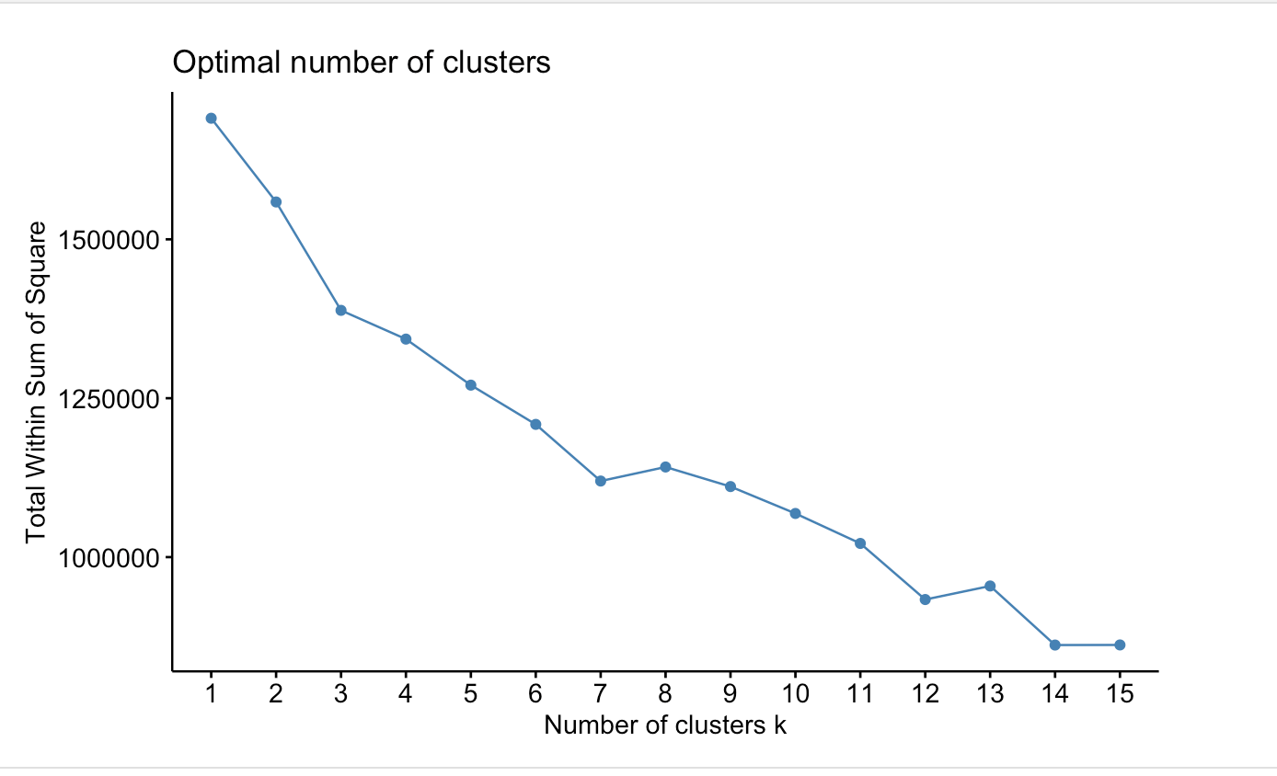

#fviz_nbclust(clust.tdm.matrix_85,kmeans,k.max=15,method = "gap_stat")

shooby_85_words = kmeans(clust.tdm.matrix_85,3)  
table(shooby_85_words$cluster) #,BCGenes$PAM50mRNA)

##   
## 1 2 3   
## 856 1061 1265

fviz_cluster(shooby_85_words,data = clust.tdm.matrix_85)

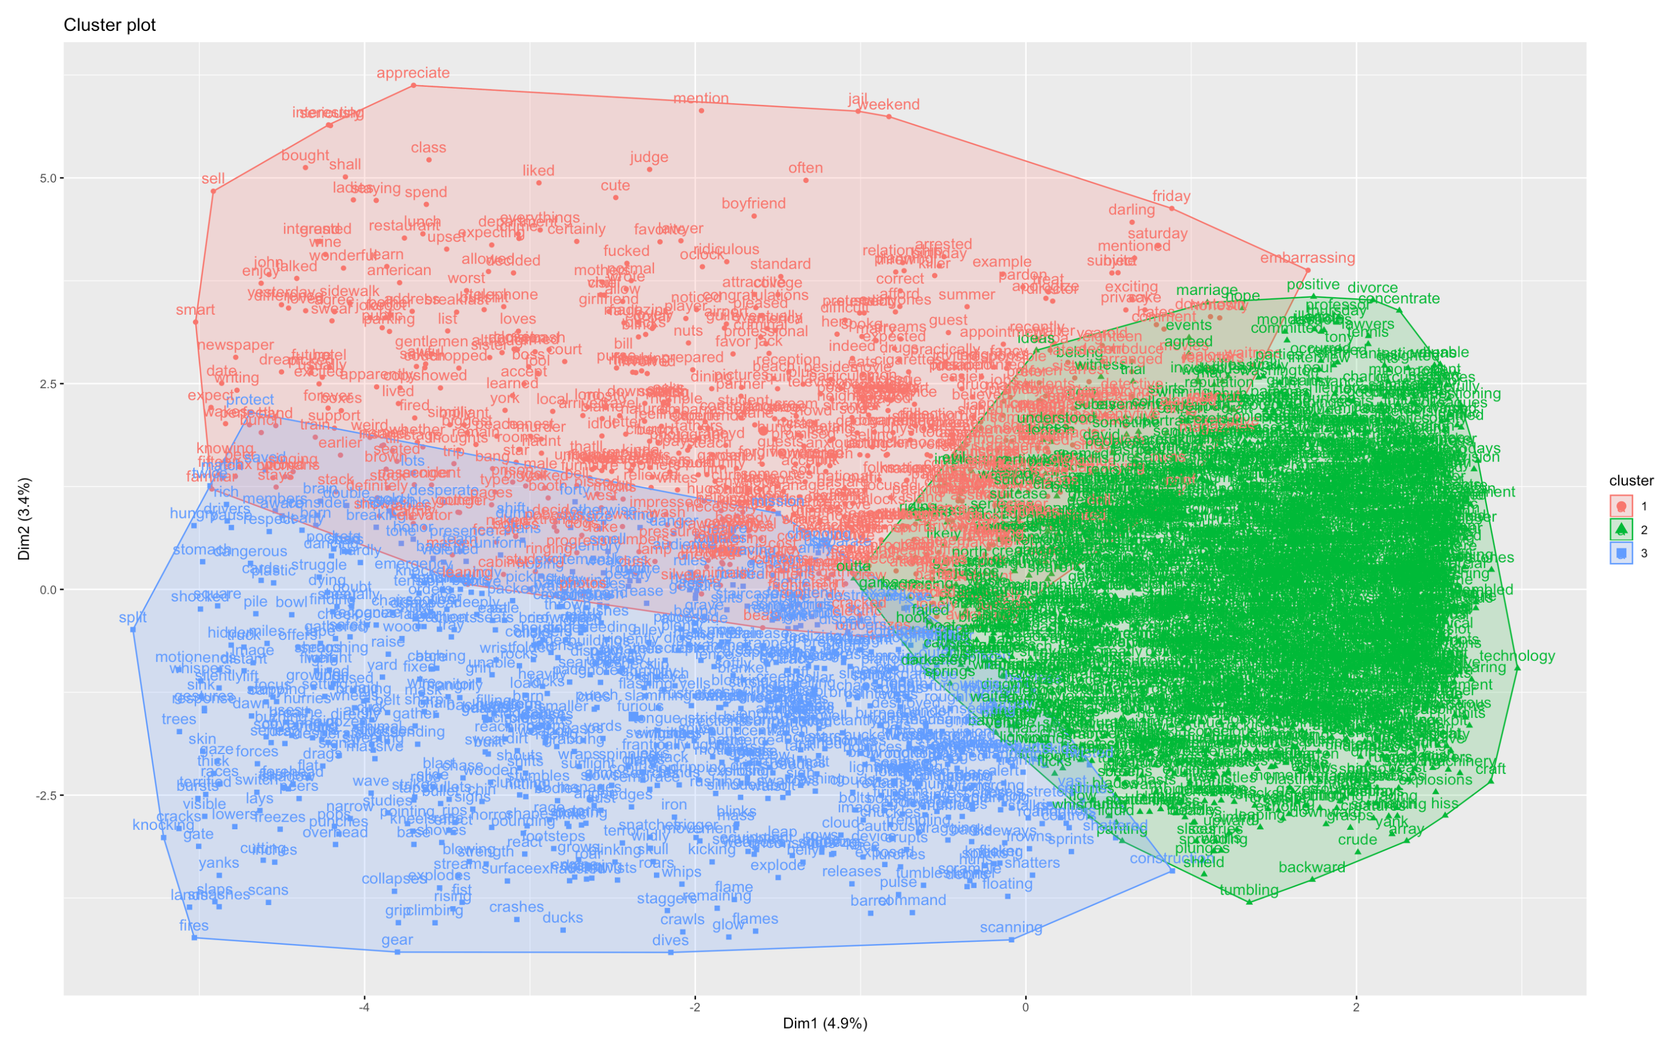

### Clustering Movies

#Clustering movies: movies as documents and words as terms: D-T  
clust.dtm.matrix_85 = dtm.matrix_85  
clust.dtm.matrix_85[clust.dtm.matrix_85>1] = 1  
  
#Clustering words: words as terms and movies as documents: T-D  
clust.tdm.matrix_85 = as.matrix(tdm_85)  
clust.tdm.matrix_85[clust.tdm.matrix_85>1] = 1

#Using Agnes  
dtm.agnes.ward_85 = agnes(clust.dtm.matrix_85, metric = "Jaccard", method = "ward")

#Plotting Agnes cluster  
plot(dtm.agnes.ward_85,cex = 0.7, which.plots = 2)

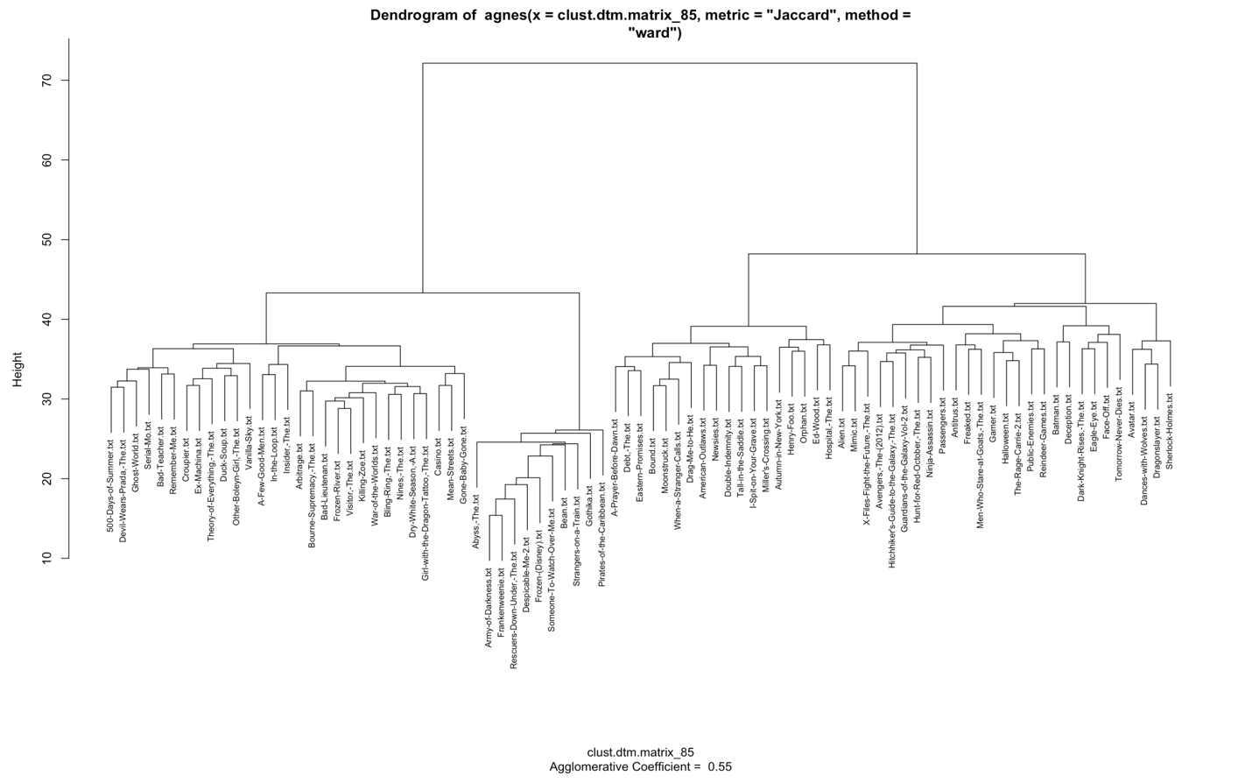

#Using hclust  
dtm.movie.dist_85 = dist(clust.dtm.matrix_85, method = "Jaccard")

#Plotting hlust  
dtm.movie.clust_85 = hclust(dtm.movie.dist_85, method = "ward.D")  
plot(dtm.movie.clust_85, cex = .7)

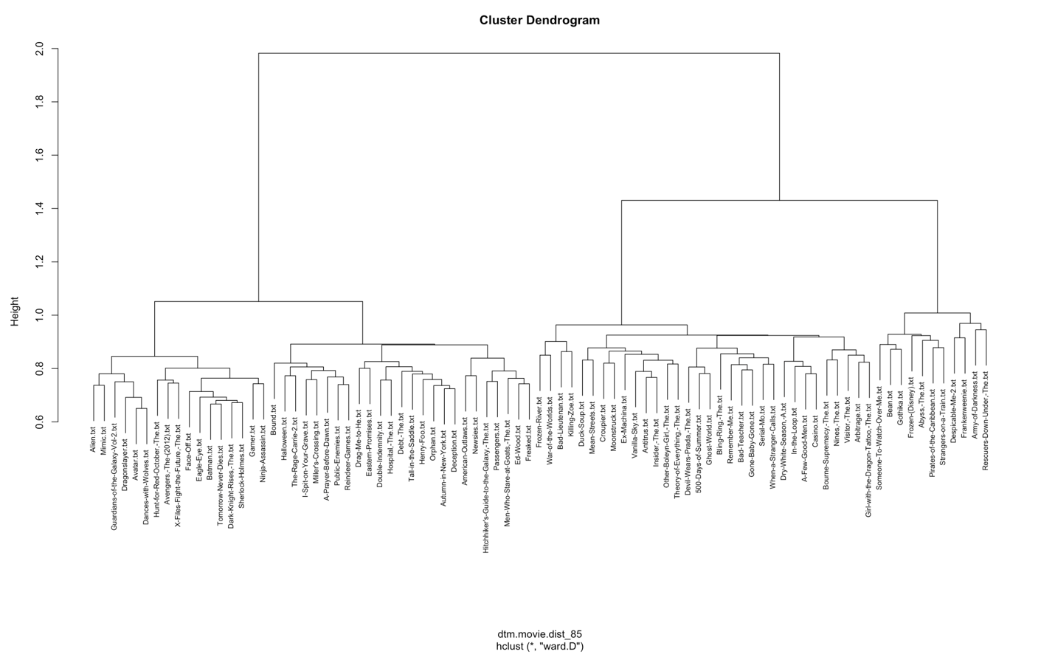

movie.groups_85 = cutree(dtm.movie.clust_85, k=6)  
table(movie.groups_85)

## movie.groups_85  
## 1 2 3 4 5 6   
## 32 25 7 17 2 2

#### K-means

#Optimal number of clusters  
fviz_nbclust(clust.dtm. matrix_85,kmeans,k.max=15,method="silhouette")

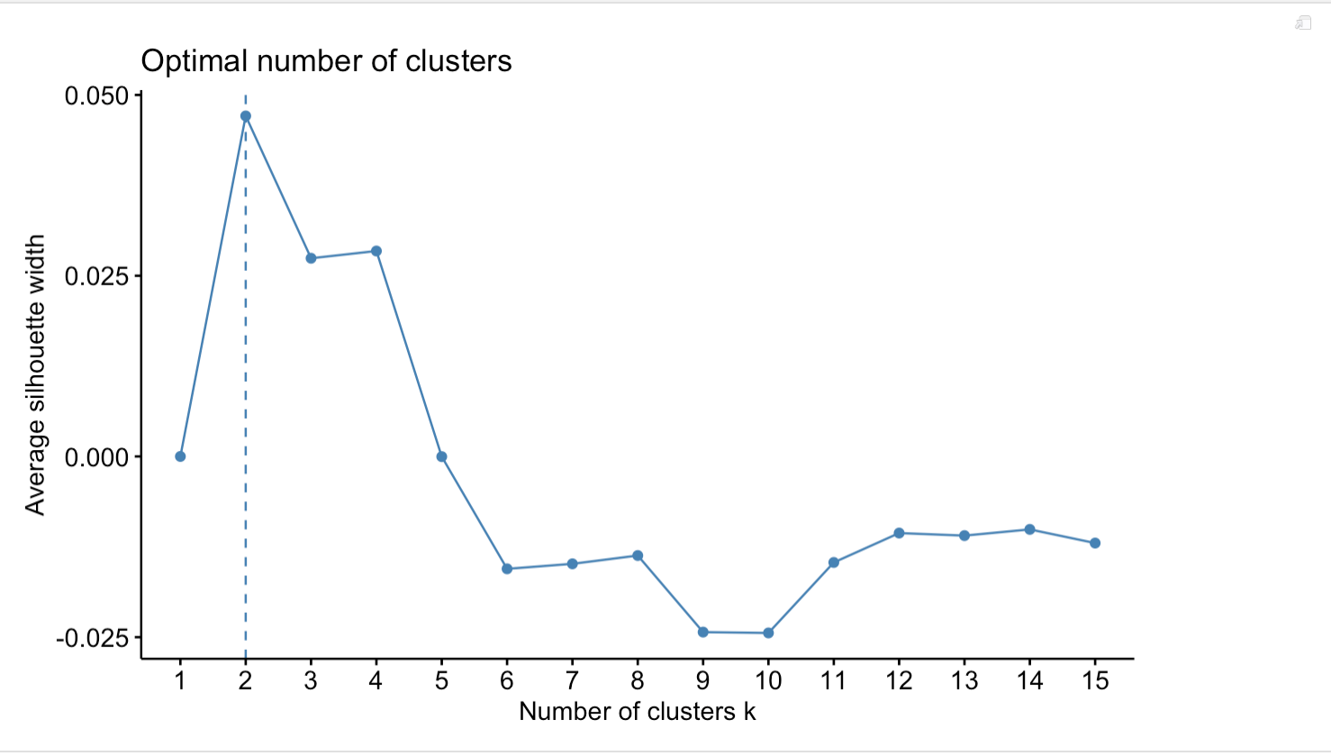

fviz_nbclust(clust.dtm.matrix_85,kmeans,k.max=15,method="wss")

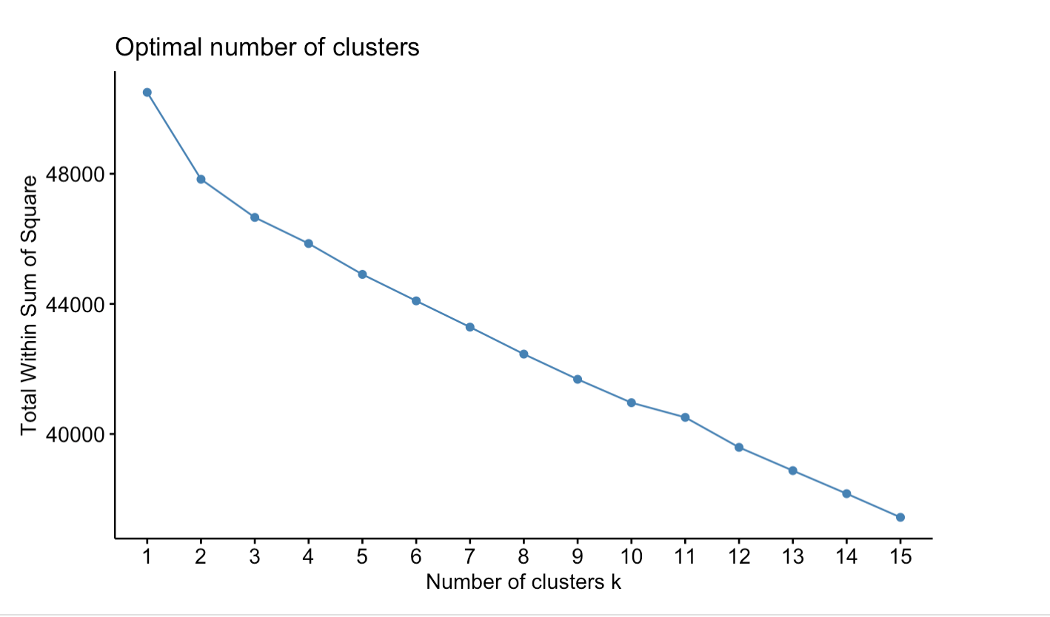

fviz_nbclust(clust.dtm.matrix_85,kmeans,k.max=15,method = "gap_stat")

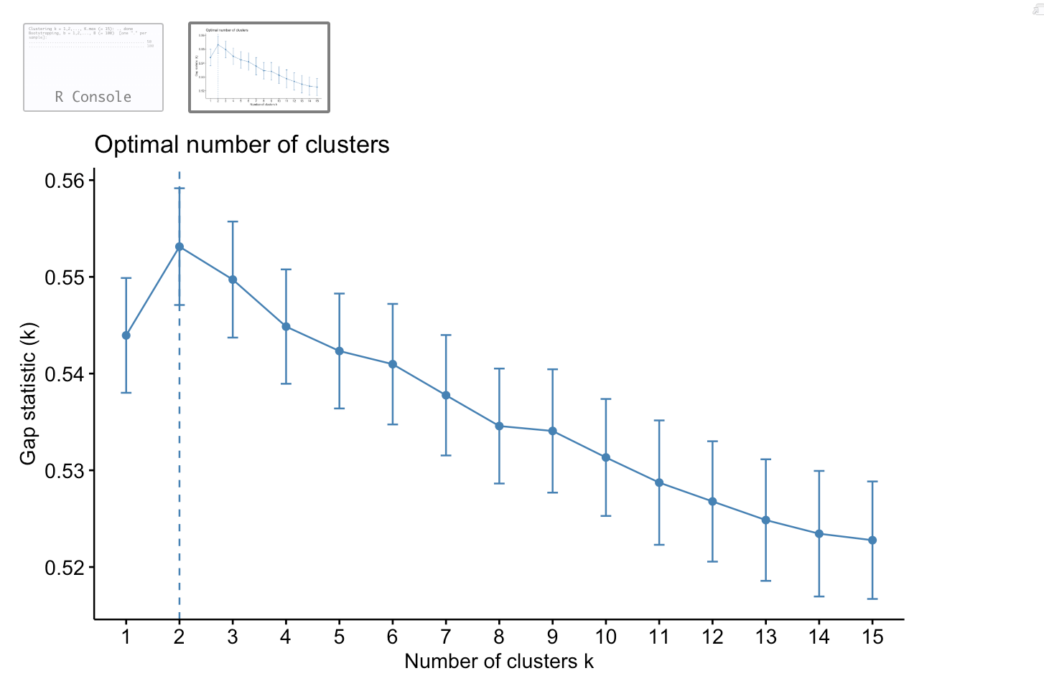

shooby_85 = kmeans(clust.dtm.matrix_85,3)  
table(shooby_85$cluster) #,BCGenes$PAM50mRNA)

##   
## 1 2 3   
## 29 35 21

fviz_cluster(shooby_85,data = clust.dtm.matrix_85)

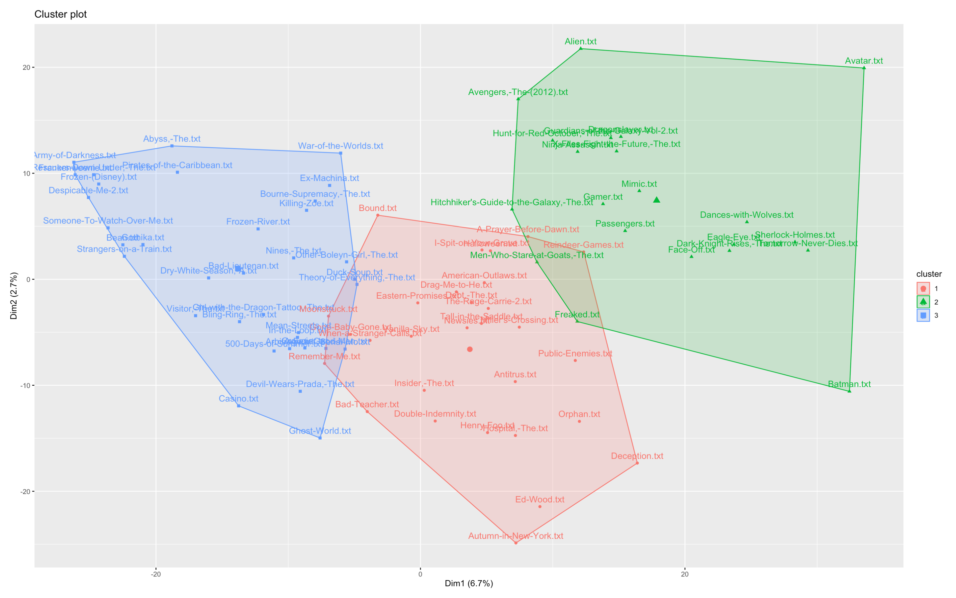

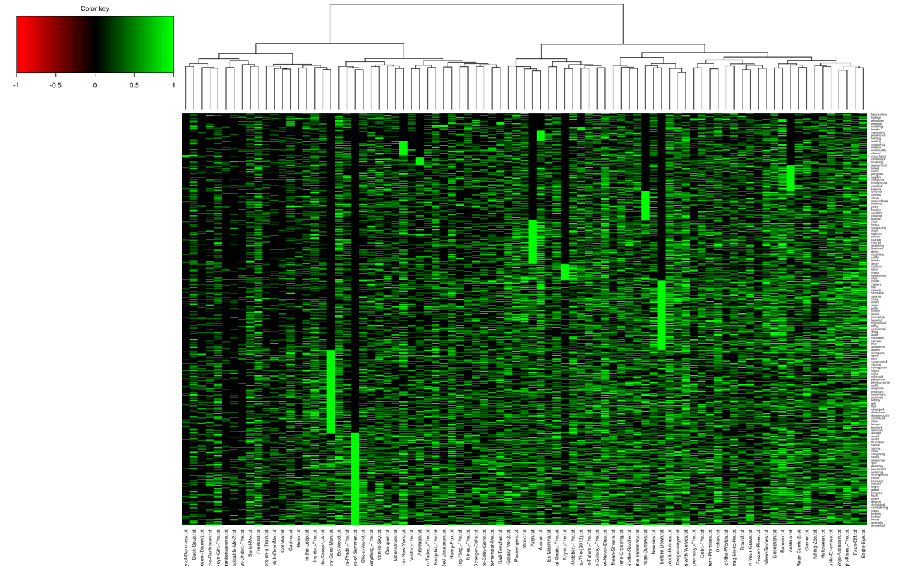

### Labels - Marshal create

### Contribution of variables and individuals -> MCA

### Association Rules: Movies as transactions and words as products purchased

#Our clust.dtm.matrix  
movie.trans_85 = as(clust.dtm.matrix_85, "transactions")  
#With support .3 and confidence .8 -> 39 rules found  
movie.rules_85 = apriori(movie.trans_85, parameter = list(supp = .2, conf =.9))

## Apriori  
##   
## Parameter specification:  
## confidence minval smax arem aval originalSupport maxtime support minlen  
## 0.9 0.1 1 none FALSE TRUE 5 0.2 1  
## maxlen target ext  
## 10 rules FALSE  
##   
## Algorithmic control:  
## filter tree heap memopt load sort verbose  
## 0.1 TRUE TRUE FALSE TRUE 2 TRUE  
##   
## Absolute minimum support count: 17   
##   
## set item appearances ...[0 item(s)] done [0.00s].  
## set transactions ...[3182 item(s), 85 transaction(s)] done [0.01s].  
## sorting and recoding items ... [2271 item(s)] done [0.00s].  
## creating transaction tree ... done [0.00s].  
## checking subsets of size 1 2 3 4 5 6 7 done [1.04s].  
## writing ... [37948 rule(s)] done [0.10s].  
## creating S4 object ... done [0.05s].

About 38,000 rules generates

plot(movie.rules_85, "grouped")

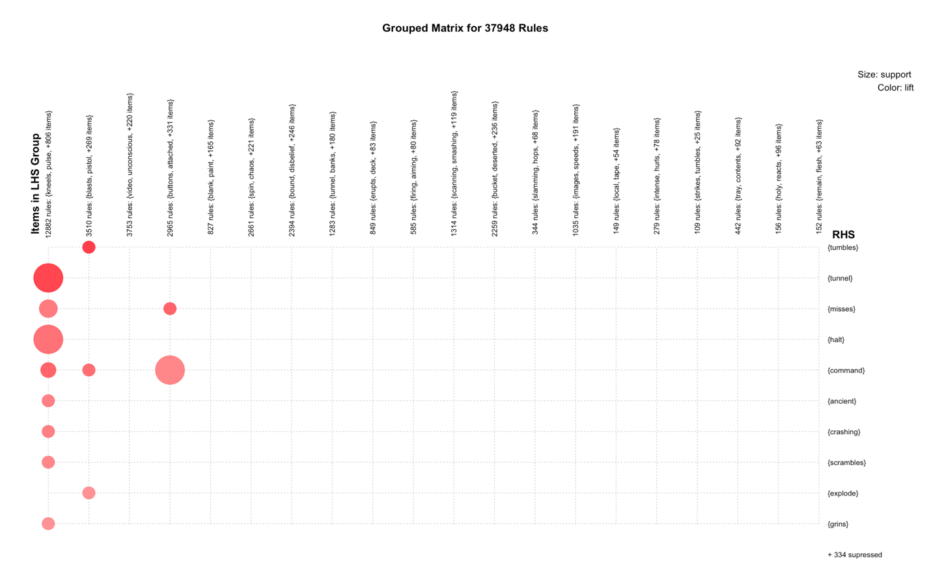

plot(movie.rules_85, "scatter", jitter = 0, interactive = F)

## Warning in plot.rules(movie.rules_85, "scatter", jitter = 0, interactive  
## = F): The parameter interactive is deprecated. Use engine='interactive'  
## instead.

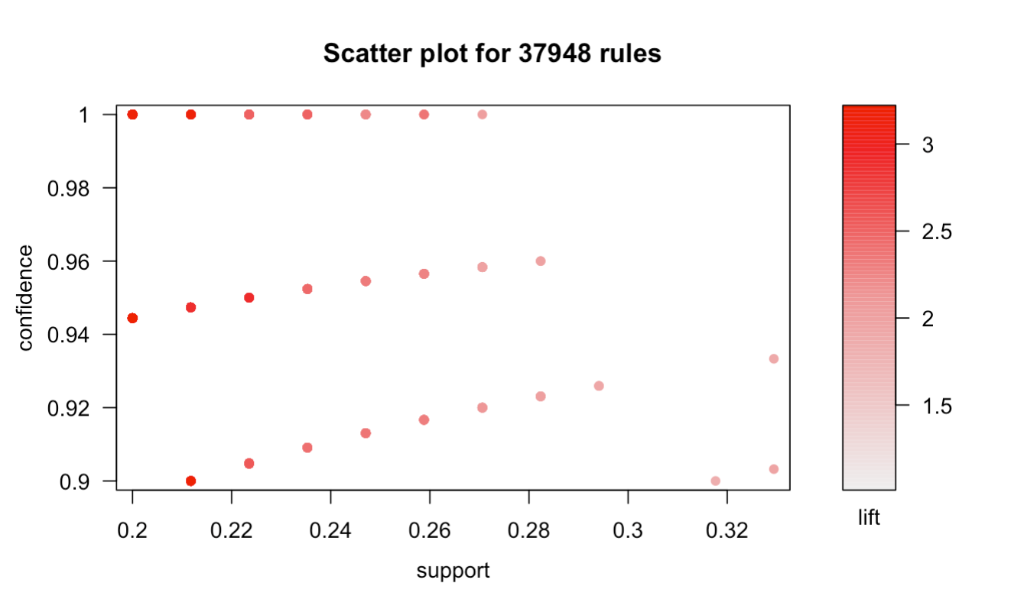

As seen above in the scatter plot, it’d be best to take rules that are the redest (highest lift value) and are in the top right corner (highest confidence and support). Let’s expore some through ruleExplorer() to determine about 10 best quality rules

Now, we are going to create subsets on rules with RHS being the most frequent word used

3 rules for 10 most frequent words:

**fuckin, ship, captain, train, elevator, dances, bridge, agent, hotel, guards**

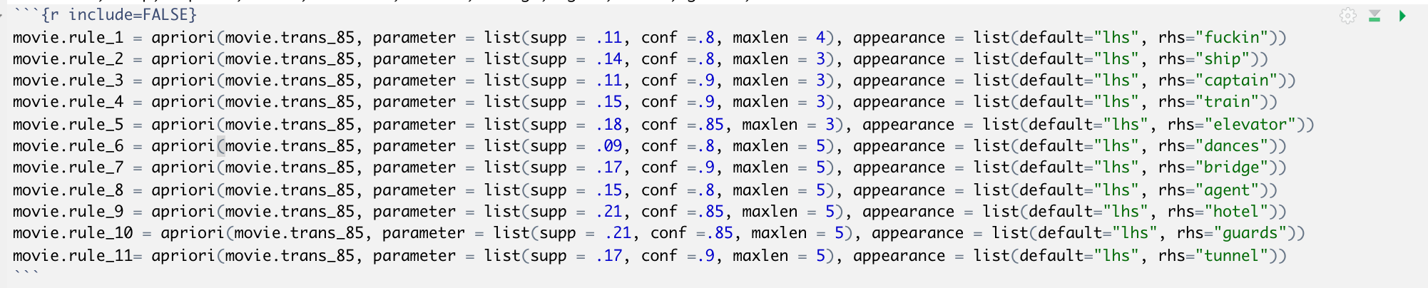

## Make plots interactive and take screenshots

movie.rule_1 = sort(movie.rule_1, by = "lift")  
inspect(movie.rule_1)

plot(movie.rule_1, "graph", interactive = F)

movie.rule_2 = sort(movie.rule_2, by = "lift")  
inspect(movie.rule_2)

## lhs rhs support confidence lift count  
## [1] {directly,ships} => {ship} 0.1411765 0.9230769 3.566434 12   
## [2] {ships,effect} => {ship} 0.1411765 0.9230769 3.566434 12   
## [3] {cutting,ships} => {ship} 0.1411765 0.9230769 3.566434 12   
## [4] {ships} => {ship} 0.1647059 0.8750000 3.380682 14   
## [5] {ships,surface} => {ship} 0.1529412 0.8666667 3.348485 13   
## [6] {safety,ships} => {ship} 0.1411765 0.8571429 3.311688 12   
## [7] {blast,ships} => {ship} 0.1411765 0.8571429 3.311688 12   
## [8] {ships,landing} => {ship} 0.1411765 0.8571429 3.311688 12   
## [9] {floating,surface} => {ship} 0.1411765 0.8000000 3.090909 12   
## [10] {directly,floating} => {ship} 0.1411765 0.8000000 3.090909 12

plot(movie.rule_2, "graph", interactive = F)

## Warning in plot.rules(movie.rule_2, "graph", interactive = F): The  
## parameter interactive is deprecated. Use engine='interactive' instead.

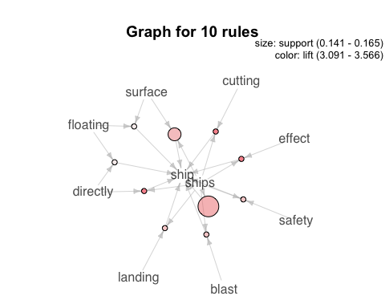

movie.rule_3 = sort(movie.rule_3, by = "lift")  
inspect(movie.rule_3)

## lhs rhs support confidence lift count  
## [1] {climbing,recovered} => {captain} 0.1176471 1.0000000 3.400000 10   
## [2] {process,reports} => {captain} 0.1294118 1.0000000 3.400000 11   
## [3] {lever,fortune} => {captain} 0.1294118 0.9166667 3.116667 11   
## [4] {reports,south} => {captain} 0.1294118 0.9166667 3.116667 11   
## [5] {panel,fortune} => {captain} 0.1294118 0.9166667 3.116667 11   
## [6] {route,sake} => {captain} 0.1294118 0.9166667 3.116667 11   
## [7] {crashing,recovered} => {captain} 0.1176471 0.9090909 3.090909 10   
## [8] {explode,recovered} => {captain} 0.1176471 0.9090909 3.090909 10   
## [9] {dropping,recovered} => {captain} 0.1176471 0.9090909 3.090909 10   
## [10] {avoid,engines} => {captain} 0.1176471 0.9090909 3.090909 10   
## [11] {armed,ocean} => {captain} 0.1176471 0.9090909 3.090909 10   
## [12] {dives,ocean} => {captain} 0.1176471 0.9090909 3.090909 10   
## [13] {safety,strains} => {captain} 0.1176471 0.9090909 3.090909 10   
## [14] {reports,route} => {captain} 0.1176471 0.9090909 3.090909 10   
## [15] {reports,panel} => {captain} 0.1176471 0.9090909 3.090909 10   
## [16] {leap,fortune} => {captain} 0.1176471 0.9090909 3.090909 10   
## [17] {pulse,panel} => {captain} 0.1176471 0.9090909 3.090909 10

plot(movie.rule_3, "graph", interactive = F)

## Warning in plot.rules(movie.rule_3, "graph", interactive = F): The  
## parameter interactive is deprecated. Use engine='interactive' instead.

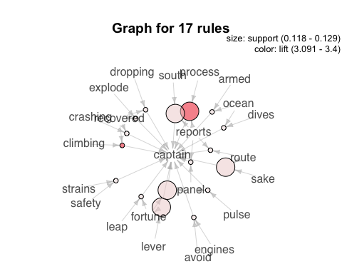

movie.rule_4 = sort(movie.rule_4, by = "lift")  
inspect(movie.rule_4)

## lhs rhs support confidence lift   
## [1] {atmosphere,public} => {train} 0.1764706 1.0000000 2.125000  
## [2] {public,rows} => {train} 0.1647059 1.0000000 2.125000  
## [3] {intense,yelling} => {train} 0.1647059 1.0000000 2.125000  
## [4] {bench,drag} => {train} 0.1882353 0.9411765 2.000000  
## [5] {hardly,noticed} => {train} 0.1764706 0.9375000 1.992188  
## [6] {intense,thousands} => {train} 0.1647059 0.9333333 1.983333  
## [7] {files,visible} => {train} 0.1647059 0.9333333 1.983333  
## [8] {familiar,slipping} => {train} 0.1647059 0.9333333 1.983333  
## [9] {passengers,switch} => {train} 0.1529412 0.9285714 1.973214  
## [10] {liar,possibly} => {train} 0.1529412 0.9285714 1.973214  
## [11] {confusion,pavement} => {train} 0.1529412 0.9285714 1.973214  
## [12] {visible,offices} => {train} 0.1529412 0.9285714 1.973214  
## [13] {willing,ghost} => {train} 0.1529412 0.9285714 1.973214  
## [14] {sidewalk,workers} => {train} 0.1529412 0.9285714 1.973214  
## [15] {knowing,workers} => {train} 0.1529412 0.9285714 1.973214  
## [16] {lovely,particular} => {train} 0.1529412 0.9285714 1.973214  
## [17] {accept,national} => {train} 0.1529412 0.9285714 1.973214  
## [18] {national,visible} => {train} 0.1529412 0.9285714 1.973214  
## [19] {rows,smashing} => {train} 0.1529412 0.9285714 1.973214  
## [20] {common,alley} => {train} 0.1529412 0.9285714 1.973214  
## [21] {common,split} => {train} 0.1529412 0.9285714 1.973214  
## [22] {directions,professional} => {train} 0.1529412 0.9285714 1.973214  
## [23] {envelope,alley} => {train} 0.1529412 0.9285714 1.973214  
## [24] {intense,envelope} => {train} 0.1529412 0.9285714 1.973214  
## [25] {sheet,envelope} => {train} 0.1529412 0.9285714 1.973214  
## [26] {knocked,envelope} => {train} 0.1529412 0.9285714 1.973214  
## [27] {paces,envelope} => {train} 0.1529412 0.9285714 1.973214  
## [28] {conference,yesterday} => {train} 0.1529412 0.9285714 1.973214  
## [29] {possibly,respect} => {train} 0.1529412 0.9285714 1.973214  
## [30] {knocked,relieved} => {train} 0.1529412 0.9285714 1.973214  
## [31] {tension,mass} => {train} 0.1529412 0.9285714 1.973214  
## count  
## [1] 15   
## [2] 14   
## [3] 14   
## [4] 16   
## [5] 15   
## [6] 14   
## [7] 14   
## [8] 14   
## [9] 13   
## [10] 13   
## [11] 13   
## [12] 13   
## [13] 13   
## [14] 13   
## [15] 13   
## [16] 13   
## [17] 13   
## [18] 13   
## [19] 13   
## [20] 13   
## [21] 13   
## [22] 13   
## [23] 13   
## [24] 13   
## [25] 13   
## [26] 13   
## [27] 13   
## [28] 13   
## [29] 13   
## [30] 13   
## [31] 13

plot(movie.rule_4, "graph", interactive = F)

## Warning in plot.rules(movie.rule_4, "graph", interactive = F): The  
## parameter interactive is deprecated. Use engine='interactive' instead.

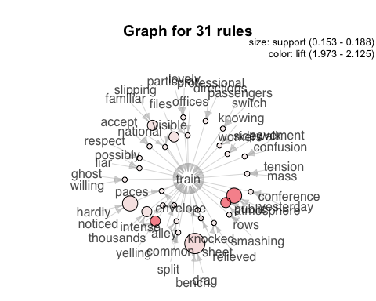

movie.rule_5 = sort(movie.rule_5, by = "lift")  
inspect(movie.rule_5)

## lhs rhs support confidence lift count  
## [1] {conference,earlier} => {elevator} 0.1882353 0.9411765 2.222222 16   
## [2] {assistant,pockets} => {elevator} 0.1882353 0.9411765 2.222222 16   
## [3] {necessary,taxi} => {elevator} 0.1882353 0.8888889 2.098765 16   
## [4] {allowed,tray} => {elevator} 0.1882353 0.8888889 2.098765 16   
## [5] {earlier,truck} => {elevator} 0.2117647 0.8571429 2.023810 18   
## [6] {catching,glimpse} => {elevator} 0.2000000 0.8500000 2.006944 17   
## [7] {clearly,sidewalk} => {elevator} 0.2000000 0.8500000 2.006944 17   
## [8] {offers,tray} => {elevator} 0.2000000 0.8500000 2.006944 17

plot(movie.rule_5, "graph", interactive = F)

## Warning in plot.rules(movie.rule_5, "graph", interactive = F): The  
## parameter interactive is deprecated. Use engine='interactive' instead.

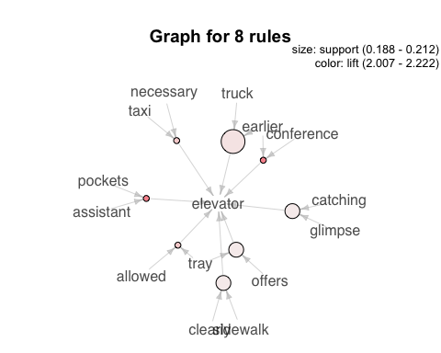

movie.rule_6 = sort(movie.rule_6, by = "lift")  
inspect(movie.rule_6)

## lhs rhs support confidence lift count  
## [1] {awkwardly,sides} => {dances} 0.10588235 0.8181818 4.090909 9   
## [2] {saturday,wallet} => {dances} 0.09411765 0.8000000 4.000000 8   
## [3] {fate,knocking} => {dances} 0.09411765 0.8000000 4.000000 8   
## [4] {peace,grips} => {dances} 0.09411765 0.8000000 4.000000 8

plot(movie.rule_6, "graph", interactive = F)

## Warning in plot.rules(movie.rule_6, "graph", interactive = F): The  
## parameter interactive is deprecated. Use engine='interactive' instead.

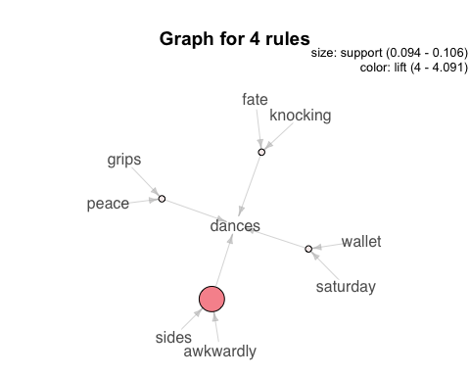

movie.rule_7 = sort(movie.rule_7, by = "lift")  
inspect(movie.rule_7)

## lhs rhs support confidence  
## [1] {races,iron,surface} => {bridge} 0.1764706 1.0000000   
## [2] {base,lowers,surface} => {bridge} 0.1882353 0.9411765   
## [3] {doubt,ends,uses} => {bridge} 0.1882353 0.9411765   
## [4] {sparks,surface} => {bridge} 0.1764706 0.9375000   
## [5] {iron,surface} => {bridge} 0.1764706 0.9375000   
## [6] {surface,climbing,releases} => {bridge} 0.1764706 0.9375000   
## [7] {inches,flashes,frantically} => {bridge} 0.1764706 0.9375000   
## [8] {distant,chin,lowers} => {bridge} 0.1764706 0.9375000   
## [9] {base,lowers,peers} => {bridge} 0.1764706 0.9375000   
## [10] {directly,inches,surface,flashes} => {bridge} 0.1764706 0.9375000   
## [11] {races,base,lowers,surface} => {bridge} 0.1764706 0.9375000   
## [12] {base,flat,lowers,race} => {bridge} 0.1764706 0.9375000   
## lift count  
## [1] 2.428571 15   
## [2] 2.285714 16   
## [3] 2.285714 16   
## [4] 2.276786 15   
## [5] 2.276786 15   
## [6] 2.276786 15   
## [7] 2.276786 15   
## [8] 2.276786 15   
## [9] 2.276786 15   
## [10] 2.276786 15   
## [11] 2.276786 15   
## [12] 2.276786 15

plot(movie.rule_7, "graph", interactive = F)

## Warning in plot.rules(movie.rule_7, "graph", interactive = F): The  
## parameter interactive is deprecated. Use engine='interactive' instead.

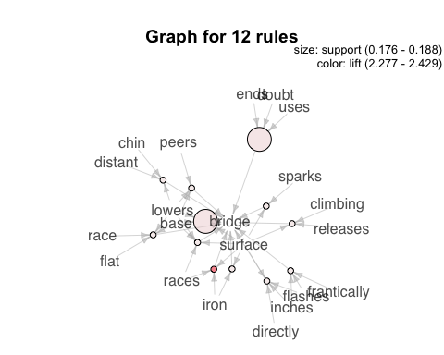

movie.rule_8 = sort(movie.rule_8, by = "lift")  
inspect(movie.rule_8)

## lhs rhs support confidence lift   
## [1] {agents,crime} => {agent} 0.1529412 1.0000000 3.148148  
## [2] {knowing,agents} => {agent} 0.1529412 0.9285714 2.923280  
## [3] {agents} => {agent} 0.1882353 0.8888889 2.798354  
## [4] {agents,dangerous} => {agent} 0.1529412 0.8666667 2.728395  
## [5] {familiar,agents} => {agent} 0.1529412 0.8666667 2.728395  
## [6] {elevator,bullet,struggle} => {agent} 0.1529412 0.8666667 2.728395  
## [7] {elevator,gear,bullet} => {agent} 0.1529412 0.8666667 2.728395  
## [8] {growing,bullet,blocks} => {agent} 0.1529412 0.8666667 2.728395  
## [9] {elevator,gear,struggle} => {agent} 0.1647059 0.8235294 2.592593  
## [10] {gear,surveillance} => {agent} 0.1529412 0.8125000 2.557870  
## [11] {dozen,government} => {agent} 0.1529412 0.8125000 2.557870  
## [12] {bringing,dozen,government} => {agent} 0.1529412 0.8125000 2.557870  
## [13] {gate,passenger,crime} => {agent} 0.1529412 0.8125000 2.557870  
## [14] {gear,bullet,inch} => {agent} 0.1529412 0.8125000 2.557870  
## [15] {freezes,bullet,inch} => {agent} 0.1529412 0.8125000 2.557870  
## [16] {bullet,scans,inch} => {agent} 0.1529412 0.8125000 2.557870  
## [17] {gate,bullet,inch} => {agent} 0.1529412 0.8125000 2.557870  
## [18] {elevator,growing,struggle} => {agent} 0.1529412 0.8125000 2.557870  
## [19] {gate,lined,passenger} => {agent} 0.1529412 0.8125000 2.557870  
## [20] {address,dozen,fires} => {agent} 0.1529412 0.8125000 2.557870  
## [21] {address,dozen,whispers} => {agent} 0.1529412 0.8125000 2.557870  
## [22] {growing,bullet,scans} => {agent} 0.1529412 0.8125000 2.557870  
## [23] {growing,bullet,dozen} => {agent} 0.1529412 0.8125000 2.557870  
## [24] {bullet,dozen,forces} => {agent} 0.1529412 0.8125000 2.557870  
## [25] {copy,gear,monitor} => {agent} 0.1529412 0.8125000 2.557870  
## [26] {gear,charges,monitor} => {agent} 0.1529412 0.8125000 2.557870  
## [27] {copy,dozen,fires} => {agent} 0.1529412 0.8125000 2.557870  
## [28] {dozen,fires,struggle} => {agent} 0.1529412 0.8125000 2.557870  
## [29] {bringing,dozen,forces} => {agent} 0.1529412 0.8125000 2.557870  
## [30] {dozen,forces,match} => {agent} 0.1529412 0.8125000 2.557870  
## count  
## [1] 13   
## [2] 13   
## [3] 16   
## [4] 13   
## [5] 13   
## [6] 13   
## [7] 13   
## [8] 13   
## [9] 14   
## [10] 13   
## [11] 13   
## [12] 13   
## [13] 13   
## [14] 13   
## [15] 13   
## [16] 13   
## [17] 13   
## [18] 13   
## [19] 13   
## [20] 13   
## [21] 13   
## [22] 13   
## [23] 13   
## [24] 13   
## [25] 13   
## [26] 13   
## [27] 13   
## [28] 13   
## [29] 13   
## [30] 13

plot(movie.rule_8, "graph", interactive = F)

## Warning in plot.rules(movie.rule_8, "graph", interactive = F): The  
## parameter interactive is deprecated. Use engine='interactive' instead.

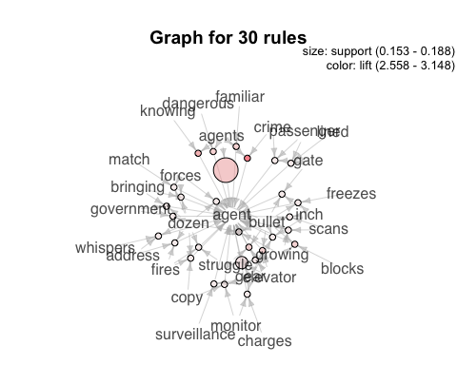

movie.rule_9 = sort(movie.rule_9, by = "lift")  
inspect(movie.rule_9)

## lhs rhs support confidence lift count  
## [1] {address,shrugs} => {hotel} 0.2235294 0.9047619 2.023810 19   
## [2] {cash,shrugs} => {hotel} 0.2117647 0.9000000 2.013158 18   
## [3] {newspaper,shrugs} => {hotel} 0.2117647 0.9000000 2.013158 18   
## [4] {shrugs,excitement} => {hotel} 0.2470588 0.8750000 1.957237 21   
## [5] {pause,shrugs} => {hotel} 0.2470588 0.8750000 1.957237 21   
## [6] {rooms,shrugs} => {hotel} 0.2352941 0.8695652 1.945080 20   
## [7] {wine,shrugs} => {hotel} 0.2235294 0.8636364 1.931818 19   
## [8] {boyfriend,expect} => {hotel} 0.2117647 0.8571429 1.917293 18   
## [9] {bill,dollar} => {hotel} 0.2117647 0.8571429 1.917293 18   
## [10] {appreciate,dollar} => {hotel} 0.2117647 0.8571429 1.917293 18   
## [11] {dollar,expect} => {hotel} 0.2117647 0.8571429 1.917293 18   
## [12] {appreciate,john} => {hotel} 0.2117647 0.8571429 1.917293 18   
## [13] {appreciate,shocked} => {hotel} 0.2117647 0.8571429 1.917293 18   
## [14] {class,shrugs} => {hotel} 0.2117647 0.8571429 1.917293 18   
## [15] {parking,shrugs} => {hotel} 0.2117647 0.8571429 1.917293 18   
## [16] {brief,shrugs} => {hotel} 0.2117647 0.8571429 1.917293 18   
## [17] {unable,shrugs} => {hotel} 0.2117647 0.8571429 1.917293 18   
## [18] {rooms,shocked} => {hotel} 0.2117647 0.8571429 1.917293 18   
## [19] {address,bunch} => {hotel} 0.2117647 0.8571429 1.917293 18   
## [20] {shrugs,john} => {hotel} 0.2117647 0.8571429 1.917293 18   
## [21] {earlier,shrugs} => {hotel} 0.2117647 0.8571429 1.917293 18

plot(movie.rule_9, "graph", interactive = F)

## Warning in plot.rules(movie.rule_9, "graph", interactive = F): The  
## parameter interactive is deprecated. Use engine='interactive' instead.

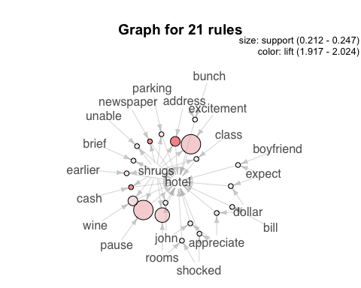

movie.rule_10 = sort(movie.rule_10, by = "lift")  
inspect(movie.rule_10)

## lhs rhs support confidence lift   
## [1] {gear,fires,drag} => {guards} 0.2117647 0.9000000 2.185714  
## [2] {fires,drag,scans} => {guards} 0.2117647 0.9000000 2.185714  
## [3] {dozen,rushing} => {guards} 0.2235294 0.8636364 2.097403  
## [4] {ends,rushing} => {guards} 0.2117647 0.8571429 2.081633  
## [5] {remain,charges} => {guards} 0.2117647 0.8571429 2.081633  
## [6] {races,backwards} => {guards} 0.2117647 0.8571429 2.081633  
## [7] {footsteps,drag} => {guards} 0.2117647 0.8571429 2.081633  
## [8] {charges,drag} => {guards} 0.2117647 0.8571429 2.081633  
## [9] {exhausted,roar,terrified} => {guards} 0.2117647 0.8571429 2.081633  
## [10] {bullet,fires,drag} => {guards} 0.2117647 0.8571429 2.081633  
## [11] {punches,forces,drag} => {guards} 0.2117647 0.8571429 2.081633  
## [12] {gear,fires,knocking} => {guards} 0.2117647 0.8571429 2.081633  
## count  
## [1] 18   
## [2] 18   
## [3] 19   
## [4] 18   
## [5] 18   
## [6] 18   
## [7] 18   
## [8] 18   
## [9] 18   
## [10] 18   
## [11] 18   
## [12] 18

plot(movie.rule_10, "graph", interactive = F)

## Warning in plot.rules(movie.rule_10, "graph", interactive = F): The  
## parameter interactive is deprecated. Use engine='interactive' instead.

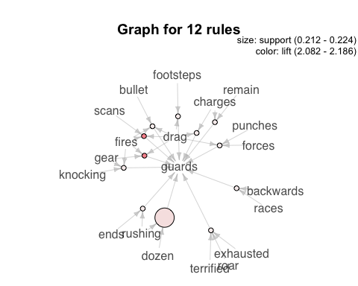

movie.rule_11 = sort(movie.rule_11, by = "lift")  
inspect(movie.rule_11)

## lhs rhs support confidence  
## [1] {gear,device,east} => {tunnel} 0.1764706 1.0000000   
## [2] {freezes,gear,device} => {tunnel} 0.1764706 1.0000000   
## [3] {gear,device,cracks} => {tunnel} 0.1764706 1.0000000   
## [4] {dozen,device,cracks} => {tunnel} 0.1764706 1.0000000   
## [5] {gear,device,explodes,cracks} => {tunnel} 0.1764706 1.0000000   
## [6] {dozen,device,explodes,cracks} => {tunnel} 0.1764706 1.0000000   
## [7] {gear,dozen,device,cracks} => {tunnel} 0.1764706 1.0000000   
## [8] {gear,device,monitor} => {tunnel} 0.1882353 0.9411765   
## [9] {gear,climbing,device} => {tunnel} 0.1882353 0.9411765   
## [10] {gear,signal,device} => {tunnel} 0.1882353 0.9411765   
## [11] {device,east} => {tunnel} 0.1764706 0.9375000   
## [12] {slide,device} => {tunnel} 0.1764706 0.9375000   
## [13] {dangerous,device} => {tunnel} 0.1764706 0.9375000   
## [14] {freezes,device} => {tunnel} 0.1764706 0.9375000   
## [15] {gear,armed,device} => {tunnel} 0.1764706 0.9375000   
## [16] {gear,anger,device} => {tunnel} 0.1764706 0.9375000   
## [17] {gear,slide,device} => {tunnel} 0.1764706 0.9375000   
## [18] {uses,climbing,device} => {tunnel} 0.1764706 0.9375000   
## [19] {gear,dangerous,device} => {tunnel} 0.1764706 0.9375000   
## [20] {gear,punches,device} => {tunnel} 0.1764706 0.9375000   
## [21] {gear,switch,device} => {tunnel} 0.1764706 0.9375000   
## [22] {gear,spinning,dropping} => {tunnel} 0.1764706 0.9375000   
## [23] {gear,spinning,weight} => {tunnel} 0.1764706 0.9375000   
## [24] {shifts,dozen,cracks} => {tunnel} 0.1764706 0.9375000   
## [25] {gear,uses,climbing,device} => {tunnel} 0.1764706 0.9375000   
## [26] {gear,shifts,dozen,cracks} => {tunnel} 0.1764706 0.9375000   
## [27] {gear,device} => {tunnel} 0.2117647 0.9000000   
## lift count  
## [1] 3.541667 15   
## [2] 3.541667 15   
## [3] 3.541667 15   
## [4] 3.541667 15   
## [5] 3.541667 15   
## [6] 3.541667 15   
## [7] 3.541667 15   
## [8] 3.333333 16   
## [9] 3.333333 16   
## [10] 3.333333 16   
## [11] 3.320312 15   
## [12] 3.320312 15   
## [13] 3.320312 15   
## [14] 3.320312 15   
## [15] 3.320312 15   
## [16] 3.320312 15   
## [17] 3.320312 15   
## [18] 3.320312 15   
## [19] 3.320312 15   
## [20] 3.320312 15   
## [21] 3.320312 15   
## [22] 3.320312 15   
## [23] 3.320312 15   
## [24] 3.320312 15   
## [25] 3.320312 15   
## [26] 3.320312 15   
## [27] 3.187500 18

plot(movie.rule_11, "graph", interactive = F)

## Warning in plot.rules(movie.rule_11, "graph", interactive = F): The  
## parameter interactive is deprecated. Use engine='interactive' instead.

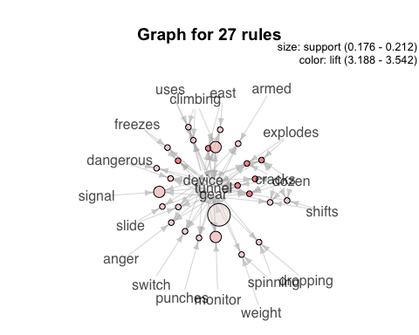

#Work on making rule subsets based on the most frequent word for example. Relate to word.frequency bar graphs

#movie.subset = apriori(movie.trans, parameter = list(supp = .1, conf =.8), appearance = list(deafault="lhs", rhs="..."))

#plot(movie.rules, "scatter", jitter = 0, interactive = T)

#Sentiment

## Word cloud for all the movies

mystopwords = c(stopwords("en"), "jack", "continued", "john")

check = Corpus(dir_85)  
check = tm_map(check, removeWords, mystopwords)

ndocs <- length(check)  
# ignore extremely rare words i.e. terms that appear in less then 1% of the documents  
minTermFreq <- ndocs * 0.15  
# ignore overly common words i.e. terms that appear in more than 50% of the documents  
maxTermFreq <- ndocs * .5  
checkDTM = DocumentTermMatrix(check,  
 control = list(  
 wordLengths=c(4, 15),  
 removePunctuation = T,  
 removeNumbers = T,  
 #stemming = T,  
 #removeWords("bateman"),  
 bounds = list(global = c(minTermFreq, maxTermFreq))  
 ))  
checkTDM = t(checkDTM)  
check.mat = as.matrix(checkTDM)

word.freq_check = sort(rowSums(check.mat), decreasing = T)  
barplot(word.freq[1:20], cex.names = .8)

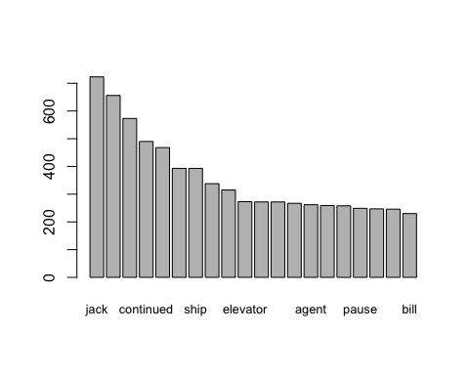

#Next 20 most frequent words  
barplot(word.freq[21:40], cex.names = .8)

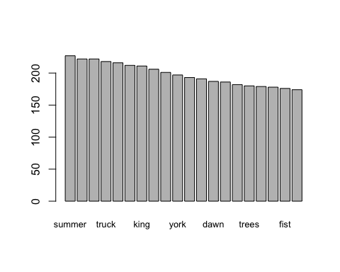

#Next 20 most frequent words  
barplot(word.freq[41:60], cex.names = .8)

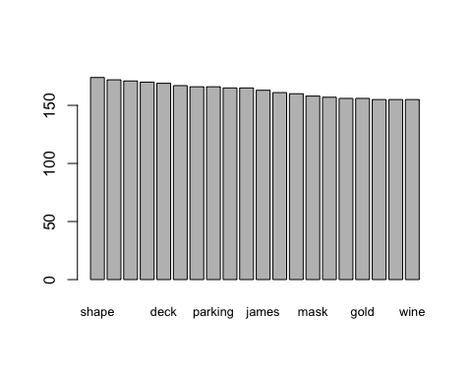

dim(check.mat)

## [1] 3200 85

# FROZEN

## Clustering of one MOVIE (words): Frozen